**Preparing for the Future of Work: Automation, AI, and Robotics**

As we accelerate into the fourth industrial revolution, a future delineated by digital technology, artificial intelligence (AI), automation, and robotics, isn't merely speculation; it's becoming our new reality. According to the [McKinsey Global Institute](https://www.mckinsey.com/featured-insights/future-of-work), over 20% of tasks performed in 2020 are likely to be automated by 2025. Furthermore, [The World Economic Forum](https://www.weforum.org/reports/jobs-of-tomorrow-mapping-opportunity-in-the-new-economy/) (2020) posits that AI and robotics will create almost 100 million new roles by 2025.

This impending transformation compels companies and their leaders to strategize and prepare their organizations for this shift.

## **The Ten-fold Impact of Automation, AI, and Robotics**

As we delve into the seismic shift shaping the future of work, let's explore the ten-fold impact of Automation, AI, and Robotics

### **Increased Efficiency**

* AI and automation can carry out repetitive tasks with unprecedented speed and precision, liberating human resources to focus on more complex, high-value jobs. A [Deloitte Insights](https://www2.deloitte.com/za/en/insights/topics/emerging-technologies/ai-adoption-challenges.html) study from 2021 revealed that integrating automation into operational workflows can augment business productivity by up to 20%, streamlining processes and boosting overall output.

### **Job Redefinition**

* As per [McKinsey's report](https://www.mckinsey.com/featured-insights/mckinsey-explainers/what-is-the-future-of-work), integrating AI into the workforce will fundamentally redefine many job roles, transforming their nature and requirements. This process will simultaneously usher in a new wave of employment categories, born directly from the increased reliance on AI and automation in the professional space.

### **Improved Decision-Making**

* The data analysis capabilities of AI can significantly enhance business decision-making. AI's ability to process and interpret colossal datasets provides businesses with nuanced insights, leading to better-informed strategic choices. According to a 2022 [PWC](https://www.pwc.com/gx/en/issues/data-and-analytics/artificial-intelligence.html) study, companies employing AI in their decision-making processes saw a 33% increase in decisions driven by robust data analysis.

### **Increased Employee Engagement**

* Automating mundane and repetitive tasks, can lead to a significant uptick in job satisfaction and productivity. A [Gallup](https://www.gallup.com/workplace/238085/robotic-process-automation-future-workplace.aspx) report from 2021 indicates that employees freed from monotonous tasks by automation, show higher levels of engagement and job satisfaction, which can directly impact organizational productivity.

### **Changing Skills Demand**

* With the rise of AI, automation, and robotics, the skill set demand within the job market is set to shift. While technical skills related to managing and leveraging these new technologies will be highly sought after, the demand for soft skills such as creativity, critical thinking, and empathy will also rise, according to the [World Economic Forum](https://www.weforum.org/reports/the-future-of-jobs-report-2020).

### **Workplace Transformation**

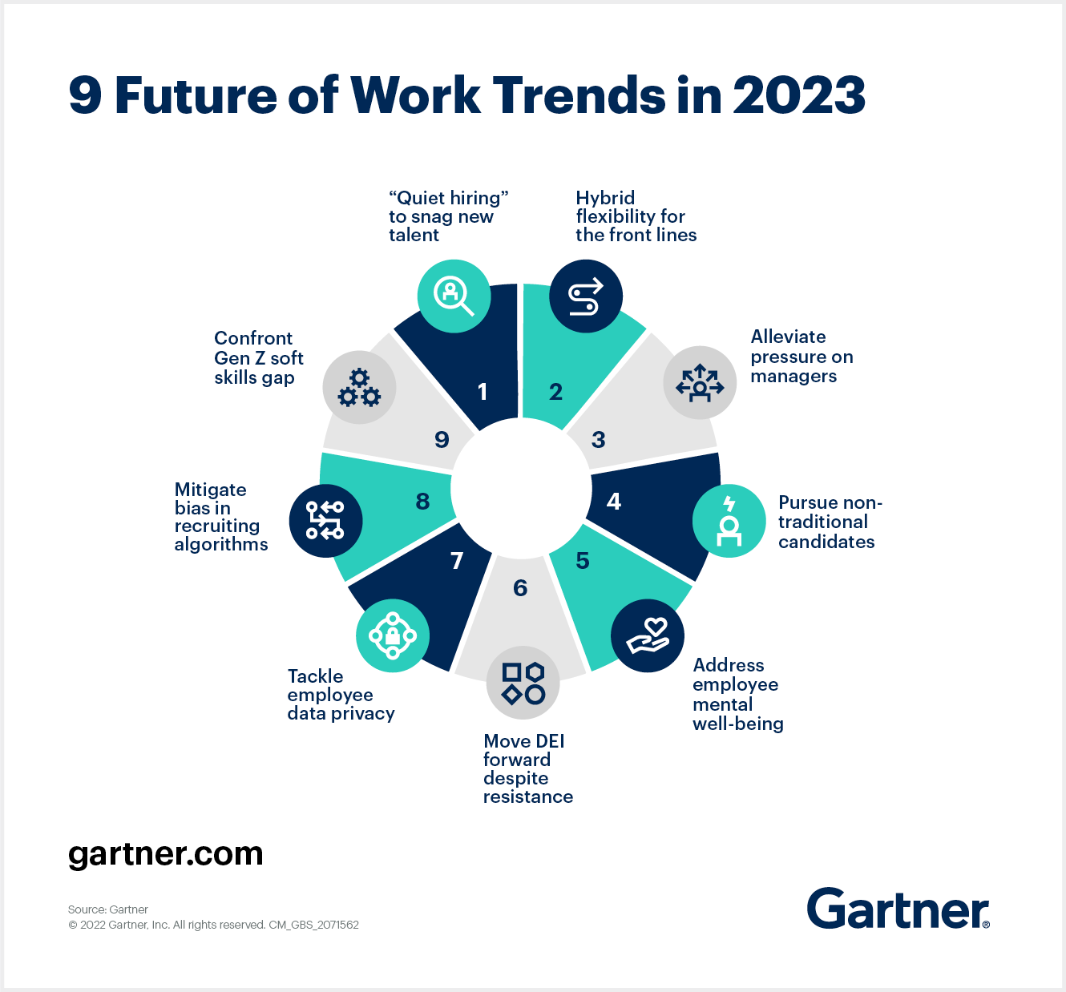

* The [Gartner report](https://www.gartner.com/smarterwithgartner/9-future-of-work-trends-post-covid-19/) suggests that as digital connectivity becomes more sophisticated and prevalent, it's likely that traditional office environments will transition to more flexible remote work arrangements, facilitated by the very advancements in technology driving the change.

### **Enhanced Customer Experience**

* AI-powered systems can significantly enhance customer satisfaction and loyalty with the ability to provide personalized and efficient service. A [Salesforce](https://www.salesforce.com/ap/hub/service/how-ai-changed-customer-service/) study in 2021 showed that 80% of customers now rate experience with a brand as equally important as the product or service offered, highlighting the necessity of AI-enabled personalization in customer interactions.

### 

### **Economic Disparity**

* Despite the productivity gains promised by automation, it could also lead to an increase in jobs lost and economic disparity. Not all workers or regions are equally equipped to transition to the new reality of AI. An [OECD](https://www.oecd.org/employment/Automation-policy-brief-2018.pdf) report from 2021 warns of the potential socio-economic implications of widespread automation.

### **Greater Innovation**

Companies that have embraced AI and automation are already reaping the rewards of heightened innovation. A 2022 [Boston Consulting Group](https://www.bcg.com/publications/2022/the-value-of-ai-for-individuals) study found that companies that have integrated AI and automation into their operations saw a 40% increase in innovation, driven by the enhanced capacity for data analysis and problem-solving, provided by these technologies.

### **Cybersecurity Risks**

* As dependence on AI, automation, and digital technology grows, so does the risk of cybersecurity threats. As per a [Cybersecurity Ventures](https://cybersecurityventures.com/jobs/) report in 2021, cybercrime costs are predicted to reach a staggering $10.5 trillion annually by 2025, emphasizing the necessity for heightened cybersecurity measures in the AI and automation age.

## **The Risks of Not Adapting to Automation, AI, and Robotics**

Organizations that fail to adapt to the evolving landscape of automation, AI and robotics, face several potential risks. Understanding these risks can help formulate strategies for successful adoption.

### **Loss of Competitive Advantage**

* Innovative technologies like automation, AI and robotics, offer [numerous benefits including cost savings, efficiency improvements, and quality enhancements](https://www.forbes.com/advisor/in/business/software/advantages-of-ai/#:~:text=Helps%20in%20Improving%20Processes%20and,workflows%20which%20are%20error-free.). Companies that fail to embrace these tools risk being outpaced by competitors who successfully harness these technologies. For instance, automated processes can complete tasks in a fraction of the time, reducing production costs and increasing output. AI can optimize resource allocation, leading to enhanced performance. Organizations relying on traditional methods may find themselves at a disadvantage, unable to keep up with more nimble and innovative competitors.

### **Talent Attraction and Retention**

* As noted by Gartner, the future workforce [expects modern technology as a part of their work environment](https://www.gartner.com/en/human-resources/trends/future-of-work-trends-post-covid-19). By shying away from these technological advancements, companies may find it harder to attract and retain the tech-savvy talent needed for a successful future. Employees want to work in a challenging, innovative environment where they can learn new skills and technologies. Companies that fail to provide these opportunities risk high employee turnover and a widening skills gap.

### **Inefficient Processes**

* Automation and AI technologies [streamline operations, minimize human error, and increase efficiency](https://www2.deloitte.com/us/en/pages/deloitte-analytics/articles/cognitive-technology-adoption-survey.html).
* 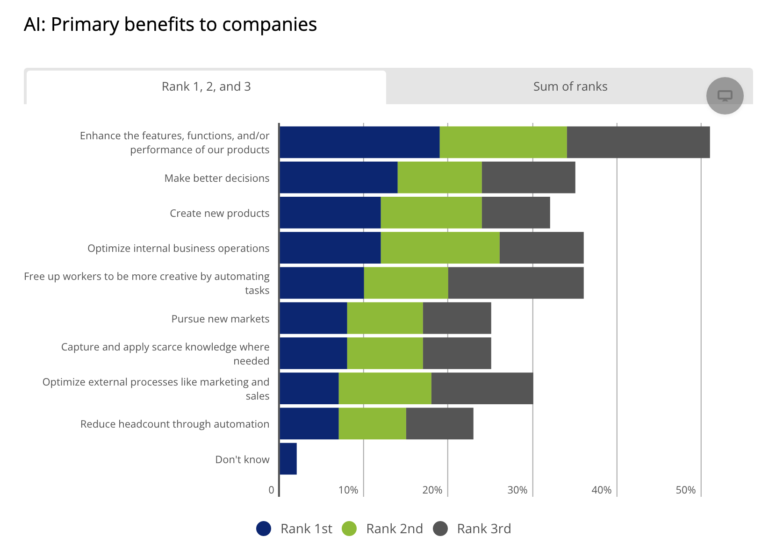

[Source](https://www2.deloitte.com/us/en/pages/deloitte-analytics/articles/cognitive-technology-adoption-survey.html)

* For example, automating manual, repetitive tasks can free up employees to focus on higher-value, strategic tasks. Companies that neglect these tools may continue to struggle with inefficient, error-prone manual processes, leading to higher operating costs and lower productivity.

### **Ineffective Decision-Making**

* AI enables companies to analyze large amounts of data and extract actionable insights, [leading to data-driven and strategic decision-making](https://sloanreview.mit.edu/article/using-ai-to-enhance-business-operations/). Without AI, companies may lack the necessary insights to make informed decisions, relying instead on intuition or incomplete information. This could result in missed opportunities or misguided strategies.

### **Decreased Customer Satisfaction**

* From AI chatbots providing round-the-clock customer service, to personalized product recommendations driven by AI, [technology can dramatically improve customer satisfaction](https://www.google.com/url?sa=t&rct=j&q=&esrc=s&source=web&cd=&cad=rja&uact=8&ved=2ahUKEwiV9LiyvuX_AhV29zgGHRjwDyIQFnoECA4QAQ&url=https%3A%2F%2Fwww.salesforce.com%2Fap%2Fresources%2Farticles%2Fcustomer-service-best-practices%2F&usg=AOvVaw3zytV71dSIf4414g3LeZe3&opi=89978449). Companies that fail to leverage these technologies might struggle to provide the same level of service, leading to lower customer satisfaction, loyalty, and potentially lower revenues.

### **Operational Resilience**

* [Automation and robotics can enhance a company's ability to adapt to changing circumstances](https://www.bcg.com/publications/2021/quality-global-business-services-post-covid-19), offering a greater degree of operational resilience. For example, during peak periods or disruptions, automated systems can scale quickly to meet demand. Companies that don't adapt these technologies may find it challenging to maintain business continuity in the face of unexpected events or rapidly changing market conditions.

### **Increased Safety Risks**

* In industries such as manufacturing or logistics, [robotics can take over tasks that are dangerous or physically strenuous for humans](https://www.osha.gov/robotics/standards), thereby improving worker safety. Companies that fail to integrate robotics into these roles may expose their workers to unnecessary risk, potentially leading to increased injuries, higher insurance costs, and potential legal issues.

As we navigate the future of work, it's clear that the adoption of automation, AI, and robotics is not merely a choice but a necessity. Ignoring these changes can lead to significant business risks. However, with a proactive, strategic approach, companies can mitigate these risks and unlock the immense potential these technologies have to offer.

## **Strategies for Future Work Preparation**

As the future of work, steered by Automation, AI, and Robotics, unfolds it becomes imperative to devise strategic approaches for effective adaptation. In this section, we'll explore practical strategies that individuals, businesses, and governments can employ to thrive in the evolving work landscape

### **Skills Training and Development**

* In light of the shifting skills demand, businesses must put an emphasis on upskilling and training their workforce to navigate the rapidly evolving technological landscape. This could involve everything from, providing comprehensive training programs on new technologies and tools, to encouraging lifelong learning through subsidizing advanced degrees or certifications in fields like data analysis or AI.

### **Adopt a Digital-First Mindset**

* As digital technologies permeate every aspect of business, organizations must adopt a digital-first approach. This goes beyond simply integrating digital solutions into existing workflows. It entails fundamentally rethinking business strategies and incorporating innovative technologies at every level, from internal communication and project management to customer interaction and service delivery. This could involve significant investments in advanced technologies and adopting cloud-based platforms, allowing seamless collaboration and communication.

### **Prioritize Cybersecurity**

* The increased reliance on digital technologies comes with its own set of risks, not least of which is the threat of cyber attacks. Businesses must invest in robust cybersecurity measures to protect sensitive data and maintain operations. This could involve hiring dedicated cybersecurity staff, investing in state-of-the-art security software, and conducting regular security audits to identify and address potential vulnerabilities.

### 

### **Redesign Jobs**

* In the era of AI and robotics, the nature of many jobs will need to be reimagined. Businesses should take a proactive role in this process, incorporating AI and robotics into job roles where these technologies can add value and improve efficiency while also leveraging unique human strengths like creativity, critical thinking, and emotional intelligence that AI cannot replicate.

### 

### **Promote a Culture of Continuous Learning**

* The rapid pace of technological change means that learning is no longer a one-time event but a continuous process. Businesses should foster a work culture that embraces change and encourages continuous learning, providing employees with the resources and opportunities they need to keep their skills up-to-date and relevant.

### 

### **Invest in AI and Robotics**

* As AI, automation, and robotics evolve, they will offer increasingly valuable business opportunities. Companies should, therefore, proactively invest in these technologies and integrate them into their operations. This might involve setting up dedicated teams or departments to explore and implement AI and robotics, or it could include partnering with external technology firms to gain access to the latest innovations in the field.

## **All Things Considered**

The landscape of work is irrevocably changing, driven by the formidable forces of automation, AI, and robotics. These technologies are no longer mere enhancements but have become fundamental components of business strategy, carrying the power to streamline operations, foster innovation, and redefine job roles. However, this transformation is not without its challenges, with risks ranging from increased cybersecurity threats to socio-economic disparities. It's crucial for organizations to not only adapt to these changes but to embrace them proactively, prioritizing skills development, fostering a digital-first mindset, and investing in robust cybersecurity measures. Organizations must also cultivate a culture of continuous learning, and redesign jobs to harness the optimal blend of human and machine capabilities. This is not an era where we have the luxury of choice - the future is being shaped by these technological advancements and it is up to us to prepare and adapt, in order to thrive in this new reality.